**ABSTRACT** Historical persecution of grizzly bears in North America reduced the species range by 55%. Today, dedicated recovery efforts and shifting societal perceptions have supported the recovery and expansion of grizzly bear populations in many areas. With increasing overlap between people and bears, conservation actions and scientific inquiry are now shifting efforts towards supporting coexistence with bears. Here we assessed the demography and behaviour of grizzly bears in a coexistence landscape in southeast British Columbia, Canada, where abundant grizzly bear populations occur among busy, human-settled valleys. Between 2016 and 2022 we captured 76 individual grizzly bears and monitored their conflict behaviour, survival, and reproduction for 160 animal-years. The cause of death for fourteen animals with a functioning collar was human-wildlife conflict (n=6), road or rail collision (n=6), unknown but human suspected (n=1), and natural (n=1). Subadult survival was the lowest recorded in North America, while adult survival was similar to other studies, suggesting an intense demographic filter for young animals. We estimate that human-caused mortality is underreported in government databases by 65%, or for every recorded mortality there are ~2 that go unreported. Reporting was especially low for road and rail mortalities. Grizzly bear mortality in the Elk Valley due to collisions and conflicts with people is an order of magnitude greater than elsewhere in British Columbia. Combining DNA- and collar-based estimates of population growth we show that grizzly bear abundance is stable due to source-sink dynamics, whereby ~7 immigrant bears per year offset the high mortality rates in the area. Grizzly bears dispersing into the valley are often young and more conflict-naïve, creating a conflict spiral that can be interrupted by reducing mortality of young animals. Creating a self-sustaining population of bears within the study area will require targeted efforts to reduce or secure attractants on private property and strategies to minimize collisions with trains and vehicles.

**KEYWORDS** carnivore, demography, genetic capture recapture, reproduction, roadkill, Ursus

**INTRODUCTION**

During the early to mid-twentieth century, grizzly bear (*Ursus arctos)* populations were dramatically reduced in North America (Mattson and Merrill 2002). The species was considered a ‘dangerous impediment to progress’ by many settlers (Peek et al. 2003), and due to shooting, trapping, and poisoning across much of the continent, the species range contracted by 53% (Laliberte and Ripple 2004). By the 1970’s grizzly bears only occupied 2% of their former range in the continental USA, leaving western Canada and the state of Alaska as the strongholds for the species in North America. As the environmental movement grew in the second half of the twentieth century and societal views of peoples’ place in nature shifted from a perspective of dominion to mutualism (Manfredo et al. 2020), the persecution of grizzly bears slowed (Bruskotter et al. 2017). In 1975 after a century of persecution, the grizzly bear was listed as a threatened species in the contiguous United States under the Endangered Species Act. For over thirty years, efforts have been made to reduce human-caused mortality of grizzly bears and increase population connectivity in the United States and Canada (Schwartz et al. 2006, Hebblewhite et al. 2022). For example, significant changes to policy and regulation in British Columbia between 1964 and 1996 restricted the hunter kill and secured persistent attractants such as open garbage dumps, reflecting the shifting public attitudes towards grizzly bears. Several populations have since recovered, some of which were once small, isolated, and in peril. Grizzly bear populations are now increasing in many areas in and around the defined US Recovery Zones in four U.S states, and in portions of southern Canada, such as in central British Columbia (McLellan 1989, Apps et al. 2014, Lamb et al. 2018, Hatter et al. 2018, McLellan et al. 2021) or expanding eastward into portions of their historic range in Alberta (Morehouse and Boyce 2016). The grizzly bear population in the Greater Yellowstone Ecosystem that was estimated at 175 individuals in 1975 has since increased 5-fold, and more than 1000 grizzlies now range into landscapes that have been dramatically transformed by people since the animals last walked there a century ago (Schwartz et al. 2006, Interagency Grizzly Bear Study Team 2021). The Yellowstone example highlights a situation that is unfolding across much of the southern distribution of grizzly bears in both Canada and the United States; successful conservation efforts have allowed the species to increase in their current range and expand into portions of their historic range. During this range recolonization grizzly bears are dispersing across, or living in, human-dominated landscapes, ushering in a new era of large carnivore conservation focused on better understanding human-bear interactions and applying innovative programs to support both parties and promote coexistence (Morehouse and Boyce 2016, Proctor et al. 2018, Morehouse et al. 2020).

Coexistence between people and wildlife is a state where both exist in shared landscapes and conduct activities necessary to life within tolerable levels of risk (Frank 2016, Lute and Carter 2020). Importantly, coexistence does not necessarily imply the situation is always peaceful, rather the situation needs to be at least demographically sustainable and without excessive burdens on either party (Frank 2016, Lute and Carter 2020, Lamb et al. 2020). While this seems like an achievable goal, plentiful conflicts still occur between grizzly bears and people as bear populations increase and expand, challenging the viability of coexistence when bears pose risks to human safety and property. Bears are not passive actors in the areas where people and bears overlap, and some grizzly bears have altered their behaviour to more nocturnal patterns to avoid conflicts with people and associated mortality. Despite this behavioural avoidance of risk, grizzly bear populations in most human-dominated landscapes are not self-sustaining. Due to high mortality rates the presence of bears in human-dominated landscapes is reliant on immigration from less disturbed areas (Lamb et al. 2020). In these emerging landscapes of coexistence, the viability of coexistence depends in part on our ability to provide the necessary tools to keep people and their property safe while allowing bears to move across landscapes, survive, and reproduce at rates that support stable populations.

The Southeastern British Columbia, Canada, is a landscape that presents both opportunity and challenges for human-bear coexistence. Here abundant grizzly bear populations occur among human-settled valleys. While the area is a hotspot of human-bear conflicts, the persistence of grizzly bears suggests there is much to learn about how grizzly bears coexist with transportation corridors, towns, intensive resource extraction, agriculture, and expanding recreation. Previous investigations into the demography of grizzly bears in the Elk Valley of southeast British Columbia used composite metrics of growth derived from DNA capture-recapture data and revealed high mortality rates were contributing to source-sink dynamics (Lamb et al. 2017). Despite the demographic evidence from DNA monitoring, there has been little progress in reducing the mortality rate for Elk Valley grizzly bears, partly because DNA data does not provide the information that wildlife managers typically seek to identify an issue and implement solutions. Because we lacked information such as cause-specific mortality, age, or vital rates measured without the influence of immigration and emigration, the specific demographic mechanisms facilitating persistence remained unresolved. We sought to understand the demographics of the population by radiomonitoring individual grizzly bears in the Elk Valley, identify what was killing them, determine whether those mortalities were being reported, and estimate vital rates by age and sex. Ultimately, the goal of this work is to 1) confirm the source-sink dynamic proposed in (Lamb et al. 2017) with more specific data that allow for decoupling of demographic processes (i.e., reproduction vs immigration), and 2) use the demographic insights from 1, combined with our collective experience following the collared bears and responding to conflicts between bears and people in communities, to propose evidence-based solutions to support wildlife managers in operationalizing coexistence between people and grizzly bears in the southeast British Columbia.

**Study Area**

The 5,073-km2 study area is in the Rocky Mountains of southeast British Columbia, Canada (Figure 1). The eastern edge of the study area extends about 7 km into Alberta, Canada. We initially defined a general study area based on the ecological trap area in Lamb et al. (2017) to guide collaring efforts but then refined the area post-hoc as the 99th percentile of a utilization distribution generated by pooling locations from all collared grizzly bears. We refer to the study area as the “Elk Valley” although the upper headwaters of the Elk River are not included (Figure 1). The study area stands out as a unique area of grizzly bear coexistence and conflict due to the moderate density of grizzly bears (15-56 grizzly bears / 1,000 km2 (McLellan 2015, Lamb et al. 2019)) living in close proximity to three towns of >5,000 people each, a highway with >10,000 vehicles per day, an active railway, five large open pit coal mines, and recreation including off-road vehicle use, mountain biking, hiking, hunting, and fishing occurring across the landscape.

**METHODS**

**Capture, handling, and collaring**

Grizzly bears were captured using multiple methods throughout their active season (April to November) between 2016 and 2022. Some bears were darted from a helicopter, but this method was not viable in all portions of the study area due to human settlement in the valley bottom. In more human-dominated areas, we captured bears in culvert traps and leg-restraining snares, which allowed us to choose captures sites based on safety concerns. Our capture effort was primarily directed toward the valley bottom and tributaries of the Elk Valley and therefore our inference primarily pertains to the areas that correspond to the clusters of telemetry locations (Figure 1).

Bears involved in human-wildlife conflict were sometimes captured by members of the British Columbia Conservation Officer Service (COS). When their capture did not end in euthanasia, we often collared these animals and included them in our sample. Although other studies have separated the demography of conflict bears from the study population, at least until a conflict bear is captured in a research trap and becomes a research animal for the rest of its life (Schwartz et al. 2006), we chose to pool all captured animals together. Unlike other studies that captured bears across large areas, both near and far from human settlements, our study focussed on bears in human-dominated landscapes and thus all the bears in our sample were at least potentially conflict animals. None of the bears first captured by the COS died while collared so their inclusion did not appear to bias our sample.

We used Vectronic VERTEX Lite collars (VECTRONIC Aerospace, Berlin, Germany) and Followit Geos collars (Followit AB, Lindesberg, Sweden), each of which took between 1 and 12 relocations a day and was equipped with a VHF beacon for real time manual locating of individuals. All collars were fitted with a cotton belt break away of varying thickness that was designed to rot within 1-5 years. In addition to the cotton belt break away, most collars were equipped with a remote blow off within the collar that was pre-programmed to activate within 2-4 years (depending on the bear’s age) that could also be activated remotely by satellite at any time. We provide additional details on traps, drug information, and handling procedures in Supporting Information A.

**Demographic monitoring**

Mortality was primarily monitored via a 12-hour inactivity switch within the collars. In addition, we opportunistically recovered dead ear-tagged animals that were no longer collared. We generally responded to mortality notifications from collars within 12 hours. Cause of death was often apparent (for example where the carcass was on a railway or highway with excessive blunt-force trauma), but it was ascertained by necropsy when cause was less clear. We assessed animal body condition either subjectively or measured accumulated fat depth over the rump. We censored collars that rotted off, were blown off, or failed. Early in the study we had poor collar performance and the GPS and VHF transmitters often stopped working prematurely. We assessed the potential for these instances to be mortalities and the collar destroyed (i.e., cryptic poaching of collared animals) by collating known outcomes determined through other means such as DNA sampling, subsequent live capture, or confirmed mortality after collar failure. All grizzly bears killed by people must be reported to a wildlife officer in BC. During this compulsory inspection, data and samples are collected and the data is stored in the BC Compulsory Inspection (CI) database. We genotyped all CI samples as part of a larger genetic monitoring program in this area (Mowat et al. 2020).

We monitored the reproduction of females via annual aerial cub surveys in May, as well as ancillary observations at subsequent captures or via remote cameras between April-November. For each observation we recorded the female identity, and the number of offspring observed and their age (cub of year, yearling, or two-year-old, etc.). In cases where we did not observe offspring as cubs of the year, it was sometimes difficult to discriminate between yearling and two-year-old bears in the field, so we used a combination of body size, mother’s age, and observations in subsequent years to estimate the age of offspring.

**Estimating demographic parameters**

We estimated survival parameters for males and females separately for three age classes: 1) dependent cubs and yearlings (0-1 years old), 2) independent subadult animals (2-6 years old), and 3) adults (>6 years old). The youngest females (n=2) to produce a littler of cubs in our study were five years old and generally younger animals appeared to produce fewer cubs until they were 7, so we estimated reproduction for females in two age classes: 5-6 and >6.

Annualized survival rates for collared animals (subadults and adults) were estimated using the Kaplan-Meier known fate and staggered entry approach over monthly time periods. Annualized survival for dependent animals (cubs and yearlings) was estimated by following the fate of litters from collared females. We estimated dependent survival as the proportion of individuals that were observed the following year with their mother. We did not include two-year-olds in this estimate because many of them are not seen with their mother as three-year-olds due to family breakup which often occurs in spring (McLellan 2015).

Annual reproduction for subadult and adult females was estimated as the total number of cubs of the year observed with collared females of each age class divided by the total number of collared females monitored in each age class (Garshelis et al. 2005). We estimated the average age of primiparity following the approach described in Garshelis et al. (1998), wherein we calculated the number of cubs produced per nulliparous female aged 5-9. We weighted these results by the proportion of the population available to produce cubs (i.e., those animals that were not currently with offspring and still alive/monitored). We were not able to calculate birth intervals due to a small sample size of females with multiple litters monitored (n=4).

We estimated the intrinsic population growth rate using a deterministic Leslie matrix, which represents the growth rate of grizzly bears without the influence of immigration and emigration and assuming a stable age distribution. The Leslie matrix included demographic transitions for animals 0-27 years old, which we populated with the age class specific vital rates calculated above. We set reproductive senescence at 27 years of age (Schwartz et al. 2003). We compared this intrinsic growth rate from collared individuals to the observed population growth calculated using genetic tags and spatial capture-recapture (SCR) (Mowat et al. 2020). The primary difference between these two measures of population growth is that intrinsic population growth only considers the influence of reproduction and survival, while observed population growth also includes immigration and emigration and thus represents the observed change in abundance through time. By calculating the difference between observed and intrinsic growth rates, immigration rates can be directly estimated; a demographic parameter that is generally challenging to estimate given the relative rarity of dispersal events, the difficulty of collaring young dispersing animals, and the broad spatial extent of sampling that would be required to sample region dispersers could be coming from (Kokko 2006, Lamb et al. 2020). We estimated uncertainty for each parameter by resampling individuals with replacement (bootstrapping) 5,000 times, estimating demographic parameters with each bootstrapped sample, and extracting the standard error and 90% confidence intervals of the resulting distribution. All analyses were conducted in Program R (R Core Team 2021). To ensure reproducibility, our analysis code and data have been posted on GitHub (https://github.com/ctlamb/ElkValley_Grizzly_Demography_22).

The long-term genetic capture-recapture dataset encompassed 4,059 detections of 849 grizzly bears across 12,000 km2 in the southern Rocky Mountains of BC between 2006 and 2021. To estimate demographic parameters for our study area and account for SCR analysis which use home range centers as the parameter of interest, we subset the genetic data to our study area (Figure 1) and reduced its size to 3,210 km2 using an interior buffer of 5 km to encompass the home range centers of bears in our study (Figure S1, available in Supporting Information). The reduced study area excluded genetically tagged bears whose home range centers were towards the edge of the study area and thus experienced less risk than our collared sample due to being further from people. The subset of genetic data encompassed 1,462 detections of 291 grizzly bears. We fit two types of SCR models to these data: 1) closed models which estimated density for each year using the ‘secr’ package (Eﬀord 2022a), and 2) open models which estimated population trend by following individuals entering and leaving the population across years using the ‘openCR’ package (Eﬀord 2022b). For both models we included covariates for sex and trap type (bait site or rub tree) as detection covariates. We included all years (2006-2021) of data to maximize the number of individuals and recaptures and thus improve precision in both the closed and open models, but we focus on the demographic estimates for the 2016-2020 period to align with our period of monitoring the collared bears.

We compiled grizzly conflict reports and mortality records by source and location across BC using the publicly available Wildlife Alert Reporting Program data (https://warp.wildsafebc.com/) and CI data to assess the degree to which the Elk Valley study area has disproportionately high levels of human-bear conflict and mortality than elsewhere in the province.

**Estimating unreported mortality**

We estimated unrecorded mortality using three methods. Because people may be more likely to report the death of a collared bear than an uncollared bear, and because sample sizes were small, we felt it was important to calculate the unreported rate in multiple ways to assess the robustness of estimates across methods. For each method we provide an overall unreported mortality rate and, where possible, a cause-specific rate.

The first method, hereafter termed the “collar fates” approach, used collar fates only. For each bear that died while wearing a functioning radiocollar, we noted whether the animal’s death was reported and recorded in the CI database. We calculated the underreporting rate by dividing the number of collared bear mortalities that were unreported by the total number of collared bear mortalities. For the second method, hereafter called the “CI ratio” method, we replicated the approach of McLellan et al. (2018) and compared the number of bears killed by COS to the number killed by other sources, both for bears wearing functioning radiocollars and for uncollared bears recorded in the CI database.



 For the third method, hereafter called the “ear tag ratio” method, we took the ratio of animals with functioning radiocollars killed by COS to those killed by other human sources (described in the CI ratio method above) and compared it to the ratio expected based on returned ear tags. Full details on the CI ratio and ear tag ratio methods, equations, and



 example calculations can be found in Supplemental Material D. Finally, we integrated the estimates from all three methods (collar fates, CI ratio, and ear tag ratio) into a single ensemble estimate. To do this, we compiled the bootstrapped results from all methods, calculated a mean result for each bootstrap iteration across methods, and reported this ensemble estimate along with its error.

**RESULTS**

**Capture, handling, and collaring**

Between 2016 and 2022 we radiocollared 70 individuals (110 capture events) and 6 bears were marked but not radiocollared. Researchers were responsible for ~92% of the captures while the remaining ~8% were caught by Conservation Officers. Bears were captured in culvert traps (n=12), free-range darting from the ground (n=6), free-range darting from a helicopter (n=15), and in leg restraints (n=77). The collared animals were captured mostly as adults (>6 years old: n=27 males; n=30 females) and subadults (2-6 years old: n=21 males; n=23 females), and one male was collared at 1.5 years old. Capture effort was concentrated in seasonal habitats, which was generally in the valley bottom of the Elk Valley in the fall. Once collared, bears ranged well beyond the valley bottom into adjacent valleys and inter-provincially (Figure 2).

Males were consistently heavier than females, and this difference increased as they aged (Figure 2). The average age of captured adults was 12 for males and 11 for females, while the oldest male was 27 and the oldest female was estimated at approximately 20 years old based on tooth wear (Table S1, available in Supporting Information). Fat levels were similar across age classes and sexes but differed through the year with increasing fat levels in the fall. As a percentage of body weight, the maximum fat level recorded was 38.6% for a female and 39.2% for a male. Bears captured due to conflicts with people were in good body condition and appeared to be as fat as, or fatter than, bears captured for research purposes (Figure 2). Bears killed due to conflicts with people had an average of 2.4 cm (n=8, range=1-4 cm) of rump fat, and those killed in road/rail collisions had 4.2 cm (n=3, range=3.5-5 cm) of rump fat, indicating generally healthy animals in both cases.

**Demographic monitoring**

We recorded mortality of 22 of the 76 marked animals (Figure 3). Of the 76 marked animals, 70 were radiocollared, and 14 died while their collar was functioning (Table 1). The other 8 marked animals that died were either never collared (only ear tagged) or were not wearing a functional collar when they died. We monitored the survival of 70 individual collared animals across 160 animal-years. The cause of death for the 14 animals with a functioning collar was human-wildlife conflict (n=6), road collision (n=2), railway collision (n=3), road or rail collision (n=1), unknown but human suspected (n=1), and natural (n=1). The human-wildlife conflict kills generally stemmed from unsecured attractants and subsequent conflicts at private residences (n=4), but one animal was killed due to habituated behaviour at a coal mine, and another was shot and killed ~2 km from town and motive of the shooter was unknown because the mortality was not reported. We suspected human causes for the one mortality of unknown cause because the animal was a 5-year-old female in good health (25% body fat) when she was captured just over a month earlier. She was found dead ~50 meters from a gravel road and ~500 meters from a highway, but due to delayed transmission of the collar’s mortality signal, the carcass was too decomposed to assess whether blunt force trauma from a collision had occurred or if she had been shot. The natural mortality was a female that died in a cliffy area near the top of a mountain. Telemetry data showed she had gone up into the cliffs and stayed there for a week before she died. When found, she was emaciated with no signs of trauma. Toxicology results suggested she was not poisoned.

All the human-caused mortalities occurred in the valley bottom, which made up less than half of the area the bears ranged across (Figure 2). Three of the mortalities occurred while collared females were with dependent offspring. In one case all three cubs and their mother were struck and killed by a train, and in another case one of two yearlings were killed with their mother in an unreported conflict mortality. In the third case we detected one of two cubs alive for the following four years after its collared mother had died and the cub (now a subadult) is currently still alive and collared. Five of the 70 radiocollared bears in our study were initially captured by Conservation Officers, but none of the 14 animals that died while collared had been involved in a conflict situation at first capture.

Of the 101 capture events where collars were deployed, the fate of the animal was known in 95 cases and unknown in 6 cases. Known fates included death (n=14), the animal was alive but had dropped its collar (n=47), or the animal was still wearing a functioning collar at the time of writing (n=17). In the remaining 23 instances, we lost connection with collars; however, we know the animals were alive in 17 of these instances due to subsequent recapture or DNA detection. In the 6 cases where the bears’ fate remained unknown, it is possible the collar was destroyed during a human-caused mortality (i.e., unreported conflict kill, poaching, or collision), but we know the majority of the connection failures were not mortalities but rather collar failures. Of the 6 unknown fates, 4 animals had last collar locations >1.5 km from a road, railway, or human settlement, suggesting the connection loss was unlikely due to a human-caused mortality. Of the remaining 2 animals with unknown fates, the last relocation for one was 0.5-1.5 km from a road, railway, or human settlement, and the other was <0.5 km. Indeed, collars involved in road and rail collisions were often severely damaged, impairing their normal function. Thus, it’s possible some of these unknown fates were undetected mortalities. However, it is also important to note that many of the collars with connection failures that were eventually confirmed to be confirmed to be simple collar failures that had also stopped working close to roads and people. For this analysis we assume the 6 unknown fates are also censored fates and not deaths while acknowledging that this assumption means we are estimating a conservative mortality rate which may be slightly higher if some of these unknown fates were deaths.

We monitored reproduction of 36 subadult and adult females across 94 animal-years and detected 23 litters of various aged offspring. Females spent 54 animal-years alone, 18 with cubs, 13 with yearlings, 7 with two-year-olds, and 2 with three-year-olds. There was an average of 1.9 cubs per litter, 1.5 yearlings, 1.4 two-year-olds, and 1.5 three-year-olds. We observed a total of 41 dependent offspring, of which 28 were monitored for more than one year. Of these 28, we observed 26 as cubs and 19 were observed with their mother the following spring while 7 presumably died. We observed 15 offspring as yearlings, of which 11 were observed with their mother the following spring at two years of age; the 4 undetected two-year-olds may have died, or they were simply not with their mother during our flight in May either due to dispersal or temporary displacement during breeding season.

We monitored the reproductive status of 16 females between the ages of 5 and 9. Two animals were known to have had a litter at 5, and one animal had a litter at 6. These were the only animals to have a litter before the age of 7. Most females were with cubs when aged 7-9 (Figure S2, available in Supporting Information). The age of first parturition was estimated at 7.2 years including all 16 females, and 7.5 years when we excluded two females that were only monitored at 9+ years old, and we could not be sure they had not had cubs previously.

**Estimating demographic parameters**

Annual survival of dependent young, 0-1 years old, was 0.73 (90% CI: 0.61-0.83) for both sexes combined, 0.60 (90% CI: 0.38-0.82) for subadult males, 0.71 (90% CI: 0.54-0.88) for subadult females, 1.0 (90% CI: 0.83-1.00) for adult males, and 0.96 (90% CI: 0.91-1.0) for adult females. Annual reproduction (female cubs/female/year) by females aged 5-6 was 0.15 (90% CI: 0.00-0.31), and 0.24 (90% CI: 0.15-0.33) for females over 6 years old. When combined in the Leslie matrix, these vital rates suggested the intrinsic population growth rate for Elk Valley grizzly bears was 0.94 (90% CI: 0.86-1.01), with 93% of bootstrapped estimates <1 (Figure 6). We assessed the sensitivity of these results to the inclusion of cub observations throughout the year versus spring only and found that population growth estimates were robust (Supporting Information C).

Open spatial capture-recapture modelling suggested the abundance of grizzly bears in the Elk Valley study area has been stable from 2006 to 2021 with an observed population growth rate of 1.01 (90% CI: 0.99-1.03). We tested whether this overall stable trend was different during our period of study (2016-2022) compared to pre-2016 and found no evidence for the more complex model structure (delta AIC=0.4). The density of grizzly bears in the Elk Valley study area between 2016 and 2021 averaged 32.0 bears/1,000 km2 (90% CI: 28.9-35.0), with an estimated population of 103 individuals (90% CI: 92.7-112.0).  Calculating the difference in the population trajectories between the observed annual population growth rate of 1.01 and the intrinsic population growth rate of 0.94, we estimated that the resident population must have been supplemented by approximately 6.9% (90% CI: 0-15) or ~7 immigrants per year (Figure 6). Indeed, we observed 3 examples of radiocollared subadult male bears immigrating into the Elk Valley study area from 77-95 km away (Figure 6). All three of these bears were eventually killed, highlighting the spatial extent of the source-sink dynamics in the Elk Valley study area and the risk immigrant bears are exposed to once settled.

Recorded conflicts and mortality were higher in the Elk Valley study area than the rest of BC. There was an average of 65.3 conflict reports per 10,000 sq.km/year in the Elk Valley compared to only 5.8 per 10,000 sq.km/year across the rest of the province (Figure 4). Hunting, a regulated source of mortality, showed a similar prevalence (mortality per unit area) in the Elk Valley compared to the rest of the province. In contrast, conflicts with people and road/rail mortalities were one to two orders of magnitude more prevalent in the Elk Valley than elsewhere (Table 2). The Elk Valley study area, which accounts for less than 1% of the grizzly bear range in BC but encompassed 33% and 42% of the provincially reported road and rail mortalities, respectively. Highway contractors and railway companies across the province are required to report all road or rail mortalities, thus we do not expect reporting compliance to explain this difference.

**Estimating unreported mortality**

Of the 13 grizzly bears killed by people that were wearing functioning radiocollars, 7 were not reported to authorities. The unreported mortalities were from road or rail collisions (n=4, 3 from road, 1 from rail or road), conflicts at private property (n=1), shot and left (n=1), and of unknown cause but where humans were suspected (n=1) (Table 1). The cause for unreported mortalities can be unique to each instance, but in general road or rail collisions were not reported because the animal was struck but did not die on the road/rail but was found dead via the collar 20-400 meters away in dense vegetation. When estimating the unreported rate, we classified the shot and left bear as a conflict kill. We estimated the unreported rate of human-caused mortality using the rate of reporting from collared bears at 0.54 (90% CI: 0.31-0.77). Although sample sizes were small, we calculated cause-specific unreported rate rates to identify any obvious differences in rates between sources. Two of 4 mortalities that resulted from conflicts with people but without CO involvement were not reported (0.50), 4 of 6 road and rail mortalities were not reported (0.67), and the unknown but human suspected mortality was not reported (1). Using the CI ratio method, we estimated the unreported rate at 0.64 (90% CI: 0.0-0.9). Using the ear tag ratio method, we estimated the unreported rate at 0.76 (90% CI: 0.54-1.0). Overall, each method generally suggested many mortalities go unreported, and the median rates were similar between methods, but confidence intervals were large.

We combined all estimates together to create an ensemble unreported rate, which was 0.65 (90% CI: 0.35-0.81). We calculated cause-specific unreported rates using both the CI and ear tag ratio methods (Table 1).

**Discussion**

Grizzly bears in the Elk Valley provide unique insights into how human-dominated landscapes shape grizzly bear behaviour and demography, and how grizzly bears in turn are slowly reshaping the behaviour of people who are adopting coexistence solutions. Grizzly bears are currently abundant in the Elk Valley despite living among 15,000 people, major highways and railways, extensive resource extraction, and widespread recreation. The Elk Valley hosts more than twice the grizzly bear density (32 bears/1,000 km2) compared to 100 km north in Banff National Park (12 bears/1,000 km2, (Whittington et al. 2018))—Canada’s flagship protected area. A desire to understand the demographic mechanisms that allowed grizzly bears to persist and apparently thrive in the Elk Valley motivated this work.

Our data show that subadult grizzly bears in the Elk Valley are surviving poorly, with up to 40% (90% CI: 18-62) annual mortality (Figure 5A). Adult animals, however, had survival rates over 95% which is as high as, or higher than, survival rates seen in other studies such as those done in Banff (Garshelis et al. 2005), Flathead Valley (McLellan 2015), northwest Montana (Mace et al. 2012), and Yellowstone ((Schwartz et al. 2006); Fig. 5C). The known cause of death from collars was consistent with other studies, with people causing most mortalities (93%, 13/14). The primary cause of death was conflicts with people due to unsecured attractants on private property (n=6) and collisions with vehicles or trains (n=6). The collared bears killed by people had between 1-5 cm of rump fat, indicating their proximity to town and transportation corridors was not due to starvation. No collared bears were killed by hunters, but the grizzly bear hunting season was closed a year after our study began. The stark discrepancy in survival between subadults and adults in the Elk Valley highlights the intense demographic filter (sensu Ford et al. 2017) that essentially provides two outcomes for a young bear: 1) learn how to avoid conflicts and stay safe near transportation corridors, or 2) likely die before adulthood.

High mortality rates were not offset by reproduction in our study population (Fig. 5B). The low intrinsic population growth rate suggested bear density in the lower Elk Valley would likely decrease by 7% a year without immigration. Without being buoyed by immigration, the bears that spend time in the lower Elk valley bottom would likely decline (population growth=0.94 [90% CI: 0.86-1.01], Figure 6A and B). However, such a decline has not been observed and bear density has been relatively stable for the past 15 years. According to local observations and population reconstructions, grizzly bear numbers had also been increasing in the area prior to our study (Hatter et al. 2018, Lamb et al. 2019, Mowat et al. 2020). The source-sink dynamic observed here appears to be currently sustainable at the broader landscape scale beyond the Elk Valley and is supported by the current level of connectivity between the Elk Valley and adjacent secure habitats. We do not know how fragile the source-sink dynamic is, and whether habitat alteration in adjacent habitats could disrupt this dynamic and impede the flow of bears needed to sustain the Elk Valley in the future.

Grizzly bears can be a challenging species for people to have living nearby. Along with the Terrace-Kitimat and Bella Coola valleys, the Elk Valley is a provincial hotspot for human-grizzly bear conflict, as evidenced by the multitude of conflicts reported each year (Figure 4C). In addition to conflicts between people and bears over unsecured attractants, grizzly bears occasionally cause physical harm to people. In the last ten years, at least five people have been attacked by grizzly bears in the Elk Valley area; this accounts for approximately half the grizzly-caused human injuries in the entire province during that period. In each case, the victims were either actively hunting or scouting for animals before hunting season. Victims often defended themselves by shooting at the bear, or in one case by stabbing the bear with an arrow. While many people live and recreate in the valley without ever having a conflict with a grizzly bear—many have never even seen a grizzly bear due to their nocturnal behavior—the consistent flurry of conflicts in the spring and fall, as well as infrequent but consistent physical confrontations, indicate human-grizzly coexistence in the Elk Valley remains challenging.

Collisions between vehicles or trains and wildlife were common in our study. Just under half (6 of 14) of the known-cause mortalities were due to collisions. Like other challenges to human-wildlife coexistence, collisions are lose-lose situations where neither party benefits. Collisions with wildlife often result in dead animals. Collisions between passenger vehicles and wildlife can end in human injury or death, damaged vehicles, and the interruption of the flow of goods and people along transportation corridors. While collisions with bears are less frequent than with other species such as deer, elk, moose, or sheep—largely due to their relative abundance on the landscape—we show here that collisions between grizzly bears and vehicles or trains are a leading cause of death contributing to unsustainable mortality rates for grizzly bears in the Elk Valley. About one third of British Columbia’s recorded grizzly bear road collisions occur in the Elk Valley. Rail collisions with grizzly bears only occur in a few areas of the province, but nearly half the recorded mortalities occur in the Elk Valley. Rail mortality through the Highway 1 corridor is a leading mortality factor for grizzly bears in Banff National Park (St. Clair et al. 2019), which is the only other place in Canada where train collisions with grizzly bears are regularly reported.

Although grizzly bears in the Elk Valley are clearly exposed to high levels of risk from various human activities on the landscape, many adult grizzly bears in our study lived near people without reported conflict. We followed multiple adult female bears, some of which also had offspring, that spent most of their active season living in the valley bottom where their daily movements involved crossing railways, highways, and spending time near residential properties. These bears were often strictly nocturnal (Lamb et al. 2020), allowing them to spend time near residences and even access human-sourced foods such as apples, without being detected by people. In contrast, subadult animals in our study often accessed human foods during the day, increasing the likelihood that they would be detected by people and be killed. Because offspring generally separate from their mothers before they are old enough to safely wear a collar, we were not able to determine if cubs raised by a savvy mother also had higher survival. However, (Morehouse et al. 2016) found conflict behaviour of mothers dictated the conflict behaviour of offspring, suggesting behaviours that reduce or promote conflicts can be learned. Currently many young bears in the Elk Valley are immigrants from areas without human settlement or transportation corridors (Figure 6), and they are likely more naïve to these risks and more prone to conflict. We thus expect conflicts in the Elk Valley could be reduced by adopting conflict reduction strategies that reduces the mortality of resident subadults and ensures high survival of resident adult female bears who know how to coexist and can continue teaching their offspring these habitats.

Although the abundance of grizzly bears appears stable in the Elk Valley, does stability subsidized through immigration, recurring seasonal damage to private property, and occasional physical confrontations signal coexistence? Coexistence likely falls along a spectrum. Take for example areas where grizzly bears have been extirpated, such as the Okanagan Valley, Peace River Valley, Lower Fraser Valley, or the prairies. Coexistence is not happening in these landscapes because grizzly bears are not present, and grizzly bears that disperse into the human-dominated portions of these areas are often killed or relocated. On the other extreme would be an environment where thousands of people and abundant grizzly bears can share the same landscapes with little risk to life or property, likely with significant behavioural adjustments from both parties. Such a landscape does not yet exist, but some are trending in that direction (Proctor et al. 2018, Morehouse et al. 2020). The Elk Valley fits somewhere in the middle of these two scenarios, with an abundant and stable grizzly bear population sharing a valley with people, but conflicts and grizzly bear mortality remain high in portions of the valley. We view this as a form of coexistence due to the consistently high number of grizzly bears that share space with people; however, the situation is far from perfect and is not “peaceful coexistence”, especially for the injured people, damaged property, and dead bears. With the goal of reducing the risk to people and property, grizzly mortality, and ultimately the reliance on immigration to sustain this population, future efforts may need to be more focused on finding ways to keep people and bears safer in the valley.

We provide evidence that grizzly bear mortality and conflicts need to be reduced in the Elk Valley study area to facilitate human-bear coexistence and a self-sustaining bear population. Nearly half of the known-cause mortalities (6 of 14) were due to direct conflicts between people and bears. Tools are increasingly available to improve the safety of people and bears, such as bear aware training and improved technologies for personal and property safety. A comprehensive review from Alaska demonstrated that bear spray improves personal safety by stopping brown bear charges at least 90% of the time, and leaves 98% of the people uninjured who deploy the spray on a bear (Smith et al. 2008). Electric fencing has been shown to be one of the most effective tools to repel grizzly bears from attractants such as livestock or fruit trees, reducing property damage by 80-100% (Johnson 2018, Khorozyan and Waltert 2020). Lethal removal of problem bears generally provides short-term relief but does not address the underlying causes of conflict, and thus is not effective long term unless lethal removal is done continuously (Khorozyan and Waltert 2020). Programs that provide bear spray training and help landowners eliminate access to attractants, such as cost shared electric fencing or removing and replacing fruit trees, have made a positive difference for coexistence when applied at a landscape scale (Proctor et al. 2018, Eneas 2020). In British Columbia there are efforts to reduce conflicts, supported by a government-private partnership called WildsafeBC, conservation groups, private funders, and some municipalities, but the lack of dedicated funds for cost share programs limits the long-term success of these solutions. However, creative solutions to reduce attractants are being trialed locally. For example, the BC Ministry of Transportation and Infrastructure implemented a program to move road killed animal carcasses in the Elk Valley to an electric fenced compound where the carcasses are not accessible to bears. Highway strikes of ungulates are very common in the Elk Valley, and previously the carcasses were often dumped in gravel pits and commonly fed on by bears (Figure 3F), so this effort removed a large bear attractant from the valley bottom. Further efforts to reduce bears’ access to unsecured attractants such as livestock, fruit trees, and garbage are needed at a landscape to meaningfully reduce conflicts and mortality.

The Province of British Columbia is supporting a different coexistence solution—a collision reduction system composed of wildlife crossing structures and fencing along Highway 3—that will keep wildlife and people safer in our study area. An ambitious, grassroots project broke ground in 2020 that aims to fence 27 kilometers of highway and build (n=3) or retrofit existing (n=7) structures to serve as wildlife crossings. This section of highway encompasses multiple collision hotspots (Lee et al. 2019), including the sites where one collared bear was killed on the highway and where another was known to be struck and killed by either a vehicle or train. The project is focused on a significant wildlife corridor connecting Canada and the USA, making it an ideal location for mitigation (Proctor et al. 2015, Lee et al. 2019, Poole and Lamb 2022). Crossing structures are used by bears regularly in Banff National Park (Sawaya et al. 2014, Ford et al. 2017), and when combined with fencing that excludes wildlife from the roadway, can reduce wildlife mortality by up to 96% (Ford et al. 2022). Currently, the only collision reduction system within the core range of grizzly bears occurs in Banff National Park, but the low density of bears in Banff limits sample sizes to measure the systems’ effectiveness on grizzly bears (Ford et al. 2022). In the Elk Valley the comparatively higher density of grizzly bears, collisions (Table 1), and the comprehensive “before” data provided here should eventually provide a robust before-after comparison of the Highway 3 projects’ effectiveness.

Several emerging trends in human behaviour and stewardship practices suggest the future could be brighter in terms of reduced human-bear conflicts if such practices are adopted at scale. We believe that creating programs to support local people and the bears who have learned to navigate these challenging areas will encourage coexistence in the Elk Valley and help redefine what the upper spectrum of coexistence could look like.

**REFERENCES**

Apps, C., D. Paetkau, B. N. McLellan, A. N. Hamilton, and B. Bateman. 2014. Grizzly bear population abundance, distribution, and connectivity across British Columbia’s southern Coast Ranges. Page 125. Aspen Wildlife Research and Ministry of Environment, Victoria, British Columbia.

Bruskotter, J. T., J. A. Vucetich, M. J. Manfredo, G. R. Karns, C. Wolf, K. Ard, N. H. Carter, J. V. López-Bao, G. Chapron, S. D. Gehrt, and W. J. Ripple. 2017. Modernization, Risk, and Conservation of the World’s Largest Carnivores. BioScience 67:646–655.

Ciarniello, L. M., M. S. Boyce, D. R. Seip, and D. C. Heard. 2009. Comparison of Grizzly Bear *Ursus arctos* Demographics in Wilderness Mountains Versus a Plateau with Resource Development. Wildlife Biology 15:247–265.

Eﬀord, M. 2022a. secr: Spatially explicit capture-recapture models.

Eﬀord, M. 2022b. openCR: Open population capture-recapture models.

Eneas, K. L. 2020. Influence of Livestock and Electrified Fences on Livestock Depredation and Habitat Selection by Grizzly Bears in the Mission Valley, Montana. University of Montana.

Ford, A. T., M. Barrueto, and A. P. Clevenger. 2017. Road mitigation is a demographic filter for grizzly bears: Road Crossing Behavior in Grizzly Bears. Wildlife Society Bulletin 41:712–719.

Ford, A. T., B. Dorsey, T. S. Lee, and A. P. Clevenger. 2022. A before-after-control-impact study of wildlife fencing along a highway in the Canadian Rocky Mountains. Frontiers in Conservation Science 3:935420.

Frank, B. 2016. Human–Wildlife Conflicts and the Need to Include Tolerance and Coexistence: An Introductory Comment. Society & Natural Resources 29:738–743.

Garshelis, D. L., M. L. Gibeau, and S. Herrero. 2005. Grizzly Bear Demographics in and around Banff National Park and Kananaskis Country, Alberta. The Journal of Wildlife Management 69:277–297.

Garshelis, D. L., K. V. Noyce, and P. L. Coy. 1998. Calculating Average Age of First Reproduction Free of the Biases Prevalent in Bear Studies. Ursus 10:437–447.

Harris, R. B., C. C. Schwartz, R. D. Mace, and M. A. Haroldson. 2011. Study design and sampling intensity for demographic analyses of bear populations. Ursus 22:24–36.

Hatter, I. W., G. Mowat, and B. N. McLellan. 2018. Statistical population reconstruction to evaluate grizzly bear trends in British Columbia, Canada. Ursus 29:1.

Hebblewhite, M., J. A. Hilty, S. Williams, H. Locke, C. Chester, D. Johns, G. Kehm, and W. L. Francis. 2022. Can a large-landscape conservation vision contribute to achieving biodiversity targets? Conservation Science and Practice 4:e588.

Interagency Grizzly Bear Study Team. 2021. Yellowstone Grizzly Bear Investigations 2021: Annual report.

Johnson, B. J. 2018. Permeability of three-strand electric fences by black bears and grizzly bears. Montana State University, Bozeman, Montana.

Keay, J. A., C. T. Robbins, and S. D. Farley. 2018. Characteristics of a naturally regulated grizzly bear population. The Journal of Wildlife Management 82:789–801.

Khorozyan, I., and M. Waltert. 2020. Variation and conservation implications of the effectiveness of anti-bear interventions. Scientific Reports 10:15341.

Kokko, H. 2006. From Individual Dispersal to Species Ranges: Perspectives for a Changing World. Science 313:789–791.

Laliberte, A. S., and W. J. Ripple. 2004. Range Contractions of North American Carnivores and Ungulates. BioScience 54:123.

Lamb, C. T., A. T. Ford, B. N. McLellan, M. F. Proctor, G. Mowat, L. Ciarniello, S. E. Nielsen, and S. Boutin. 2020. The ecology of human–carnivore coexistence. Proceedings of the National Academy of Sciences 117:17876–17883.

Lamb, C. T., A. T. Ford, M. F. Proctor, J. A. Royle, G. Mowat, and S. Boutin. 2019. Genetic tagging in the Anthropocene: scaling ecology from alleles to ecosystems. Ecological Applications 29:e01876.

Lamb, C. T., G. Mowat, B. N. McLellan, S. E. Nielsen, and S. Boutin. 2017. Forbidden fruit: human settlement and abundant fruit create an ecological trap for an apex omnivore. Journal of Animal Ecology 86:55–65.

Lamb, C. T., G. Mowat, A. Reid, L. Smit, M. Proctor, B. N. McLellan, S. E. Nielsen, and S. Boutin. 2018. Effects of habitat quality and access management on the density of a recovering grizzly bear population. Journal of Applied Ecology 55:1406–1417.

Lee, T., D. A. P. Clevenger, and D. C. Lamb. 2019. Amendment: Highway 3 Transportation Mitigation for Wildlife and Connectivity in Elk Valley of British Columbia. Page 60. Miistakis Institute, Calgary, Alberta.

Lute, M. L., and N. H. Carter. 2020. Are We Coexisting With Carnivores in the American West? Frontiers in Ecology and Evolution 8:48.

Mace, R. D., D. W. Carney, T. Chilton-Radandt, S. A. Courville, M. A. Haroldson, R. B. Harris, J. Jonkel, B. Mclellan, M. Madel, T. L. Manley, C. C. Schwartz, C. Servheen, G. Stenhouse, J. S. Waller, and E. Wenum. 2012. Grizzly bear population vital rates and trend in the Northern Continental Divide Ecosystem, Montana: NCDE Grizzly Population Trend. The Journal of Wildlife Management 76:119–128.

Manfredo, M. J., E. G. Urquiza-Haas, A. W. Don Carlos, J. T. Bruskotter, and A. M. Dietsch. 2020. How anthropomorphism is changing the social context of modern wildlife conservation. Biological Conservation 241:108297.

Mattson, D. J., and T. Merrill. 2002. Extirpations of Grizzly Bears in the Contiguous United States, 1850-2000. Conservation Biology 16:1123–1136.

McLellan, B. N. 1989. Dynamics of a grizzly bear population during a period of industrial resource extraction. III. Natality and rate of increase. Canadian Journal of Zoology 67:1865–1868.

McLellan, B. N. 2015. Some mechanisms underlying variation in vital rates of grizzly bears on a multiple use landscape: Variation in Grizzly Bear Vital Rates. The Journal of Wildlife Management 79:749–765.

McLellan, B. N., G. Mowat, and C. T. Lamb. 2018. Estimating unrecorded human-caused mortalities of grizzly bears in the Flathead Valley, British Columbia, Canada. PeerJ 6:e5781.

McLellan, M. L., B. N. McLellan, R. Sollmann, and H. U. Wittmer. 2021. Vital rates of two small populations of brown bears in Canada and range‐wide relationship between population size and trend. Ecology and Evolution 11:3422–3434.

McLoughlin, P. D., M. K. Taylor, H. D. Cluff, R. J. Gau, and R. Mulders. 2003. Demography of barren-ground grizzly bears 81:8.

Morehouse, A. T., and M. S. Boyce. 2016. Grizzly bears without borders: Spatially explicit capture-recapture in southwestern Alberta. The Journal of Wildlife Management 80:1152–1166.

Morehouse, A. T., T. A. Graves, N. Mikle, and M. S. Boyce. 2016. Nature vs. Nurture: Evidence for Social Learning of Conflict Behaviour in Grizzly Bears. PLOS ONE 11:e0165425.

Morehouse, A. T., C. Hughes, N. Manners, J. Bectell, and T. Bruder. 2020. Carnivores and Communities: A Case Study of Human-Carnivore Conflict Mitigation in Southwestern Alberta. Frontiers in Ecology and Evolution 8:2.

Mowat, G., L. Smit, C. Lamb, and N. Faught. 2020. South Rockies grizzly bear inventory: progress report 2006-2019. Page 25. Province of BC, Nelson, BC.

Peek, J., J. Beecham, D. Garshelis, F. Messier, S. Miller, and D. Strickland. 2003. Management Of Grizzly Bears In British Columbia: A Review By An Independent Scientific Panel. Page 90. Minister of Water, Land and Air Protection Government of British Columbia, Victoria, B.C.

Poole, K., and C. Lamb. 2022. Migration, movements and survival in a partially migratory elk population in southeast British Columbia. Page 56. Sparwood & District Fish & Wildlife Association.

Proctor, M. F., S. E. Nielsen, W. F. Kasworm, C. Servheen, T. G. Radandt, A. G. Machutchon, and M. S. Boyce. 2015. Grizzly bear connectivity mapping in the Canada-United States trans-border region: Grizzly Bear Connectivity Mapping. The Journal of Wildlife Management 79:544–558.

Proctor, M., W. Kasworm, K. Annis, A. MacHutchon, J. Teisberg, T. Radandt, and C. Servheen. 2018. Conservation of Threatened Canada-USA Trans-border Grizzly Bears Linked to Comprehensive Conflict Reduction. Human–Wildlife Interactions 12.

R Core Team. 2021. R: A language and environment for statistical computing. R Foundation for Statistical Computing, Vienna, Austria.

Sawaya, M. A., S. T. Kalinowski, and A. P. Clevenger. 2014. Genetic connectivity for two bear species at wildlife crossing structures in Banff National Park. Proceedings of the Royal Society B: Biological Sciences 281:20131705.

Schwartz, C. C., M. A. Haroldson, G. C. White, R. B. Harris, S. Cherry, K. A. Keating, D. Moody, and C. Servheen. 2006. Temporal, Spatial, and Environmental Influences on the Demographics of Grizzly Bears in the Greater Yellowstone Ecosystem. Wildlife Monographs 161:1–68.

Schwartz, C. C., K. A. Keating, H. V. Reynolds, V. G. Barnes, R. A. Sellers, J. E. Swenson, S. D. Miller, B. N. McLellan, J. Keay, R. McCann, M. Gibeau, W. F. Wakkinen, R. D. Mace, W. Kasworm, R. Smith, and S. Herrero. 2003. Reproductive maturation and senescence in the female brown bear:11.

Smith, T. S., S. Herrero, T. D. Debruyn, and J. M. Wilder. 2008. Efficacy of Bear Deterrent Spray in Alaska. Journal of Wildlife Management 72:640–645.

St. Clair, C. C., J. Backs, A. Friesen, A. Gangadharan, P. Gilhooly, M. Murray, and S. Pollock. 2019. Animal learning may contribute to both problems and solutions for wildlife–train collisions. Philosophical Transactions of the Royal Society B: Biological Sciences 374:20180050.

Wakkinen, W. L., and W. F. Kasworm. 2004. Demographics and population trends of grizzly bears in the Cabinet–Yaak and Selkirk Ecosystems of British Columbia, Idaho, Montana, and Washington:12.

Whittington, J., M. Hebblewhite, and R. B. Chandler. 2018. Generalized spatial mark-resight models with an application to grizzly bears. Journal of Applied Ecology 55:157–168.

**FIGURE CAPTIONS**

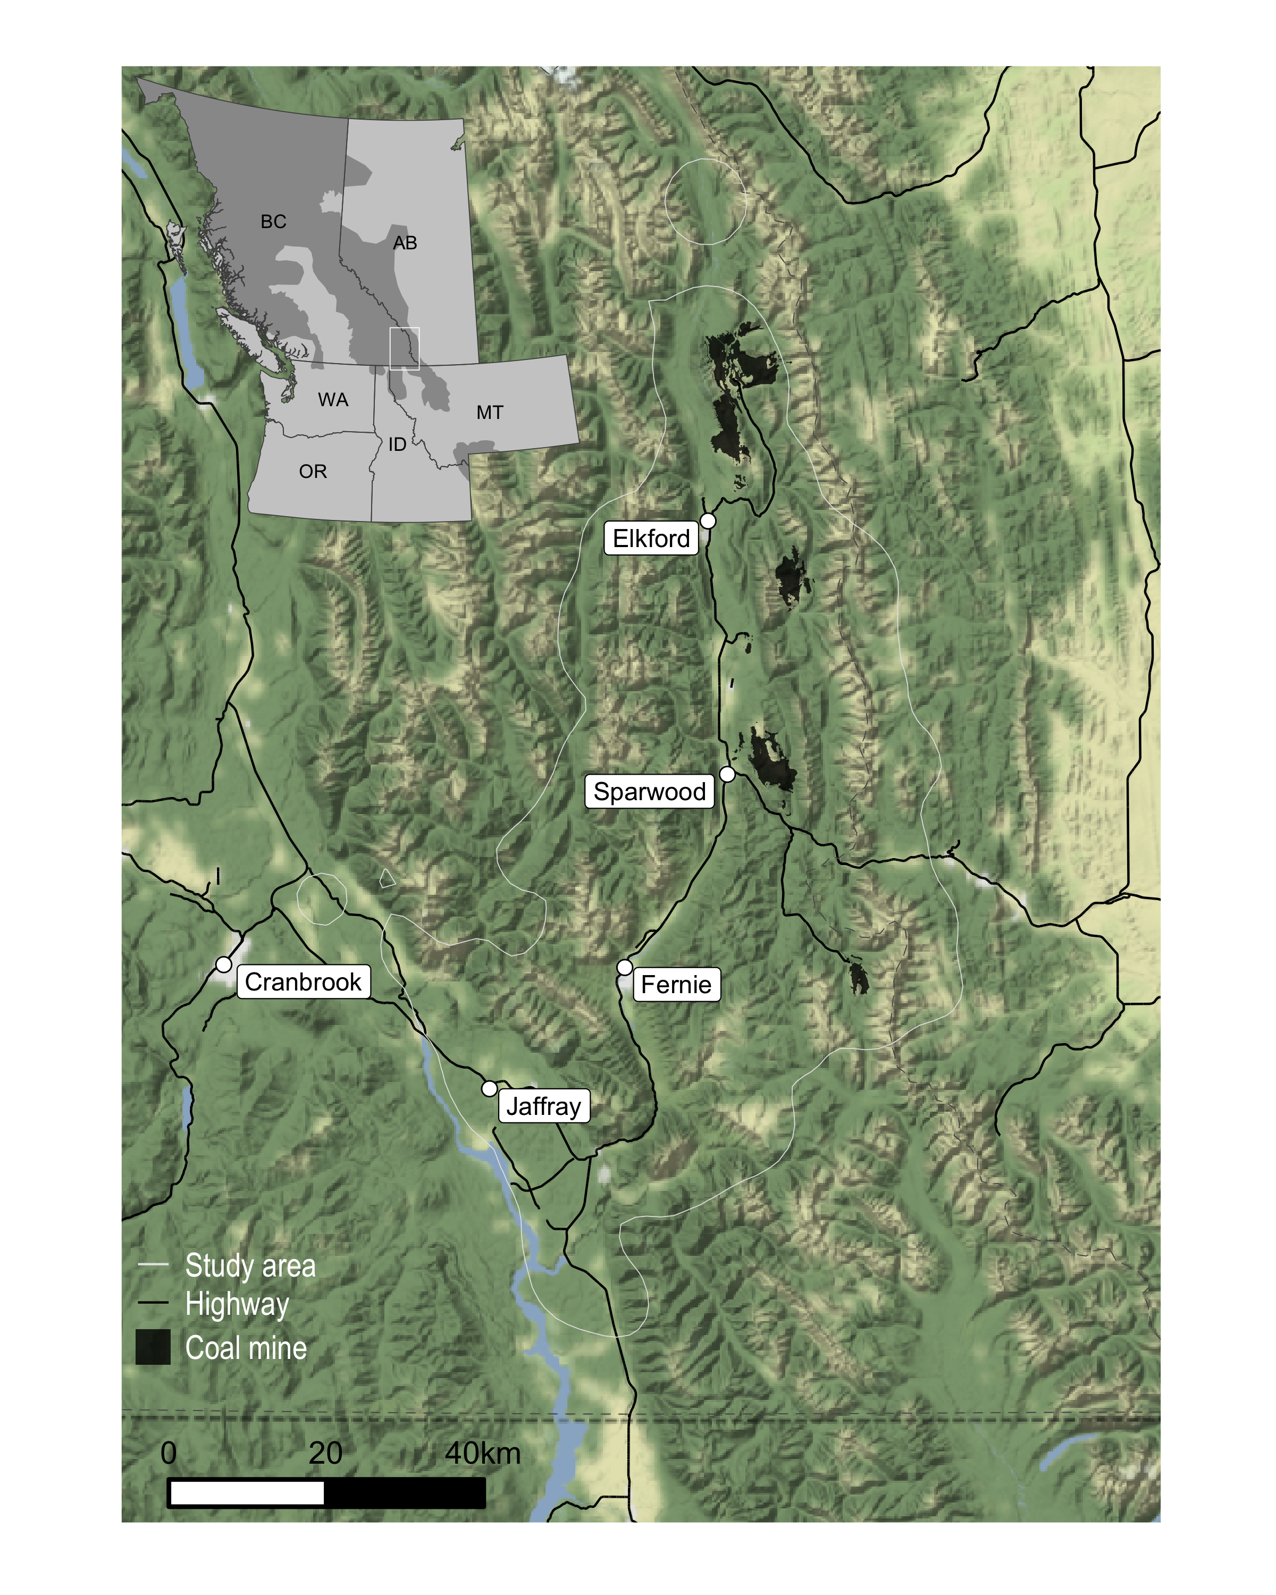

Figure 1. Study area in the Elk Valley of southeast British Columbia between 2016 and 2022 is enclosed by the white line and is the 99% Utilization Distribution of collared bear relocations. Inset map shows the southern range of grizzly bears (dark shaded area) across western North America. Building density from Microsoft Building Footrpints (https://github.com/Microsoft/CanadianBuildingFootprints).

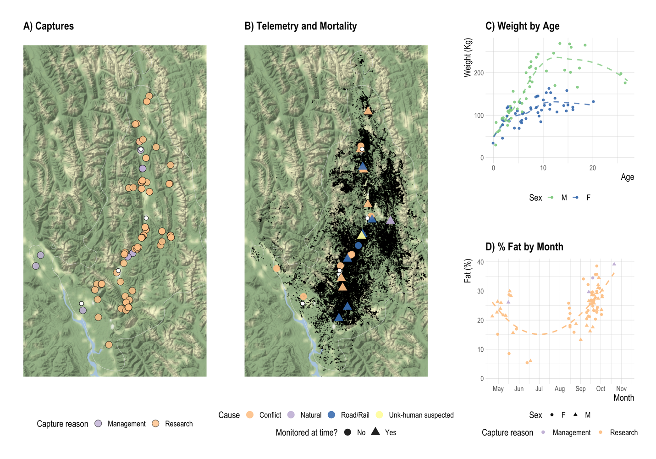

Figure 2. Elk valley grizzly bear capture, telemetry, and mortality data collected between 2016 and 2022. A) capture locations, B) telemetry and mortality locations, C) capture weight (kg) by sex and age with trend line fitted using locally weighted smoothing (LOESS), and D) percent body fat at capture, measured using bioimpedance.

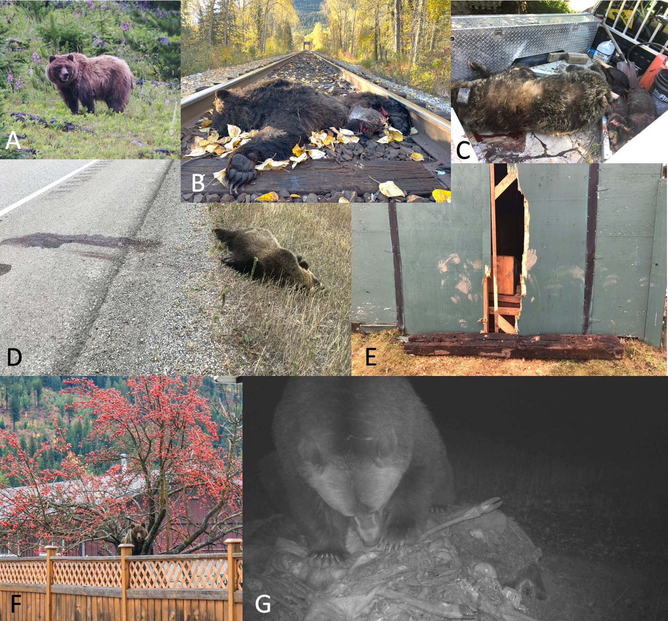

Figure 3. Collage depicting the life, death, and conflict of grizzly bears in the Elk Valley between 2016 and 2022. A) A grizzly bear in the upper Elk River, BC. B) An adult female grizzly bear (EVGF97) killed by a train; her three cubs were also killed in the same collision. C) A subadult female grizzly bear (EVGF54) in the back of a BC Conservation Officer truck with two dead pigs. EVGF54 was shot by a landowner while she was attacking their pigs. The landowner had an electric fence, but it was not maintained and had shorted out due to long vegetation against the fence, rendering it ineffective. D) A young male grizzly bear killed on Highway 3 near Hosmer, BC. E) The cost of conflict to landowners. EVGF73 and her cubs’ paws can be seen on the door of this chicken coop that she opened. She and one of her yearling cubs were illegally killed, and not reported, on an adjacent property one year later. F) A subadult grizzly bear in an unpicked crab apple tree in Elkford, BC. G) A grizzly bear eating a road killed deer in the valley bottom.

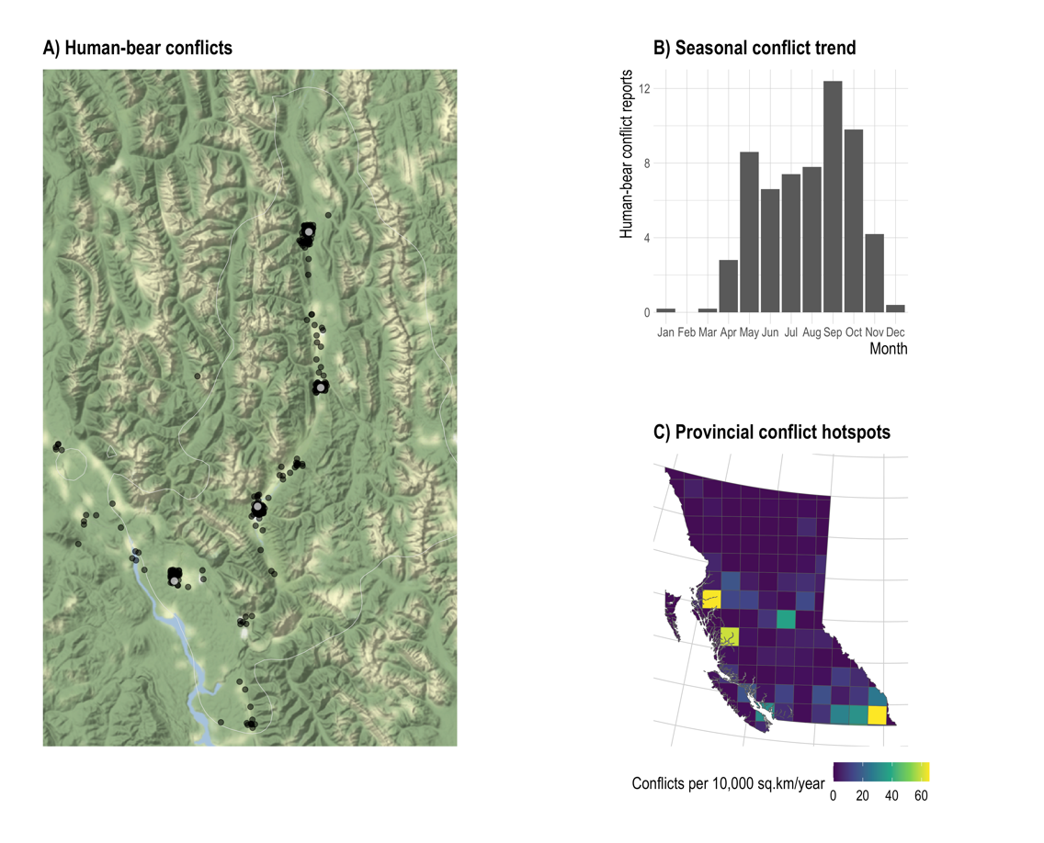

Figure 4. Reported human-bear conflicts as recorded in the Wildlife Alert Reporting System in A) the Elk Valley study area between 2016 and 2021, B) seasonally within (A) per year, and C) across the province between 2016 and 2021. The Elk Valley study area in southeast BC has the highest rate of reported human-bear conflicts in the province (~65.3 conflict reports per 10,000 sq.km/year). The mean number of conflicts per 10,000 sq.km/year is 5.8 across the province. The Lower Skeena valley near Kitimat and Terrace in west-central BC has a similar rate (64.8) to the Elk Valley.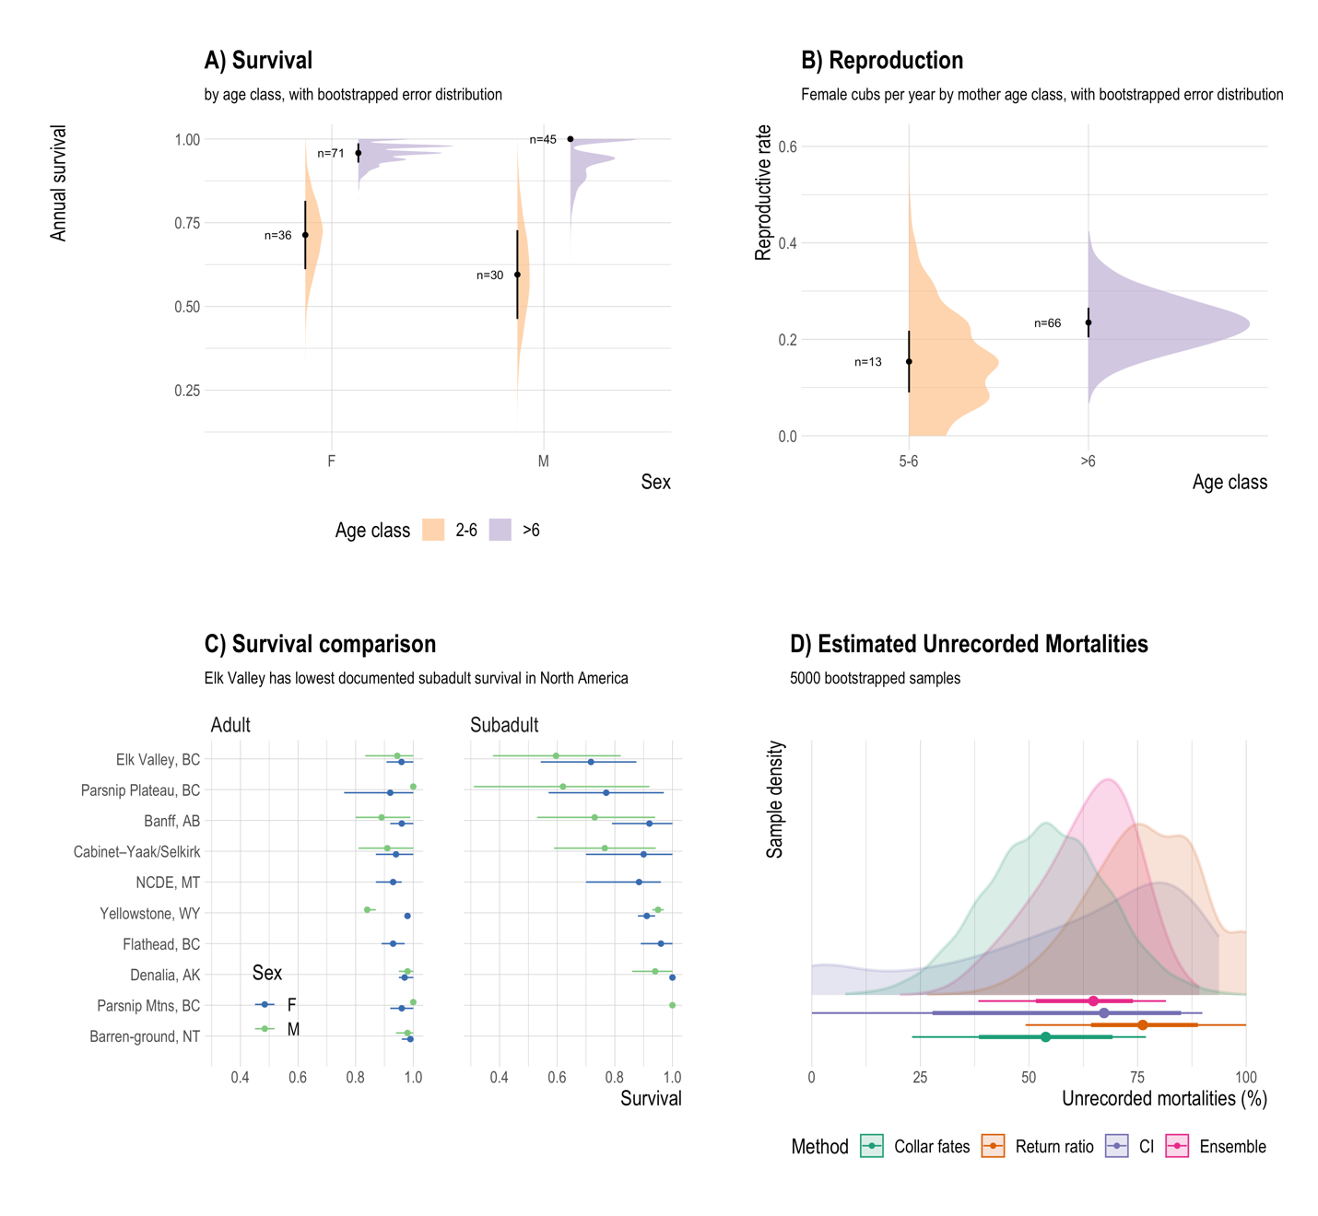

Figure 5. Elk Valley grizzly bear demographic data collected between 2016 and 2022. Distributions represent the density of bootstrapped samples. A) Annual survival rates with standard error bars. B) Reproductive rates with standard error bars. C) Comparison between Elk Valley survival rates and published rates from across North America; error bars are 95% CIs (McLoughlin et al. 2003, Wakkinen and Kasworm 2004, Garshelis et al. 2005, Schwartz et al. 2006, Ciarniello et al. 2009, Harris et al. 2011, McLellan 2015, Keay et al. 2018). D) Estimated unrecorded mortality; thick error bars cover 66% of the bootstrapped samples, and thin error bars cover 95%.

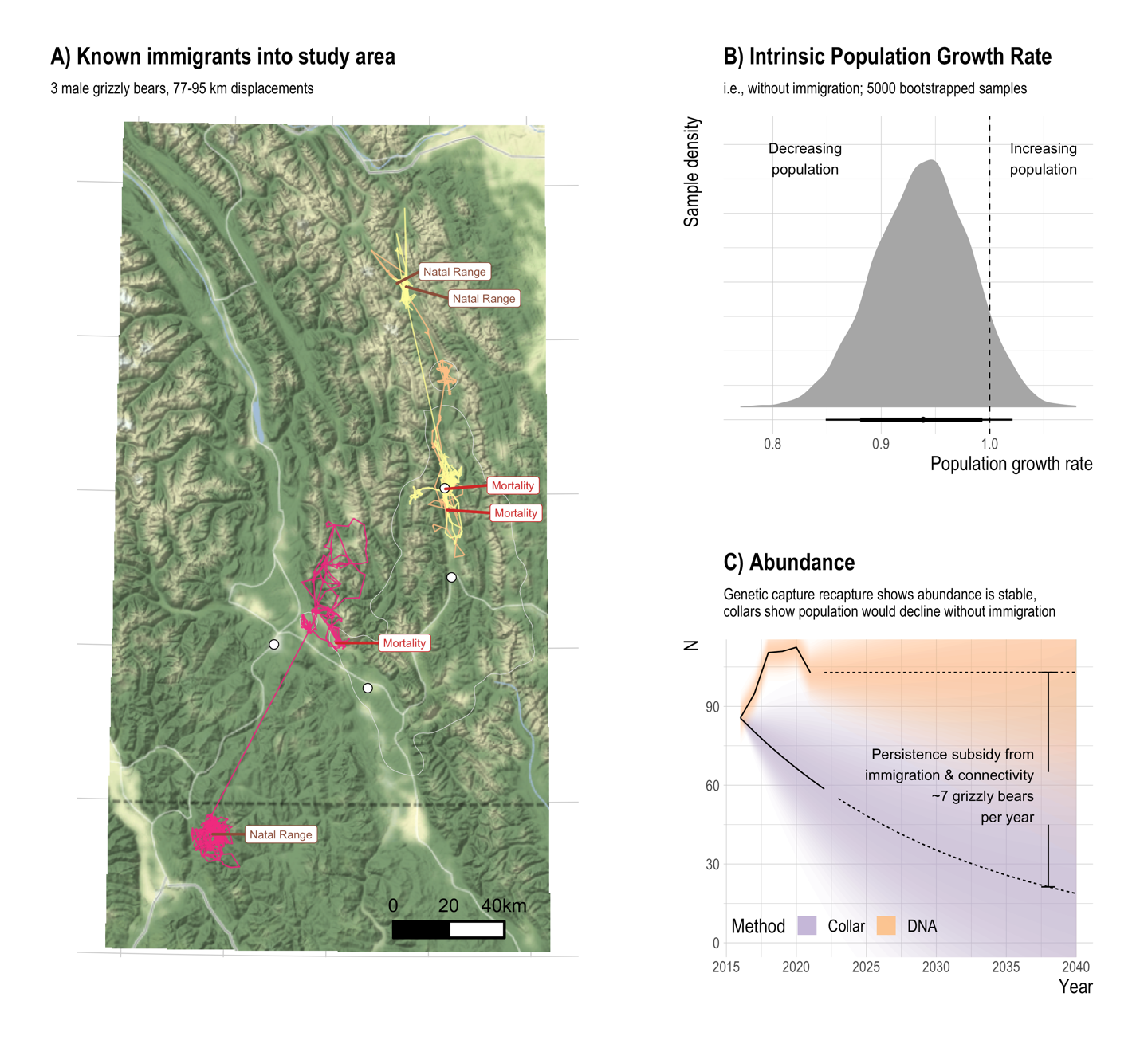

Figure 6. Source-sink dynamics in the Elk Valley. A) Known immigrants from Alberta, Canada and Montana, USA into the Elk Valley between 2016 and 2022. These immigrants were all young ($≤$ 4) males and came from 77-95 km away. B) Intrinsic population growth rate of Elk Valley grizzly bear population (i.e., without immigration and emigration). Thick error bars cover 66% of the bootstrapped samples, and thin error bars cover 95%. C) Abundance of grizzly bears in the Elk Valley estimated from genetic spatial capture-recapture analysis (DNA) between 2016 and 2021 and predicted from collar-based intrinsic population growth rate from (B, Collar). Population trends were projected out to 2040 for the total population (DNA) using the 2016-2021 growth rate from the open spatial capture-recapture model, and for a simulated population without immigration (Collar).

**TABLES**

Table 1. Mortality of collared animals while monitored, as well as human-caused grizzly mortalities reported in the CI database, and the number of ear-tagged animals known to have died by each mortality source between 2016 and 2022. The collar fates method estimates underreporting using unreported/monitored for actively collared animals killed by human causes (n=13). Unreported but monitored animals are shown in brackets. The CI ratio method uses the approach of McLellan et al. (2018) and compares the number of bears killed by COS with functioning radiocollars to those killed by other sources, for bears wearing functioning radiocollars and for uncollared bears recorded in the CI database. The ear tag ratio method uses the return ratio of ear tags of previously live-captured animals to radiocollar-monitored animals for COS kills and creates an expected number of tags returned for each mortality source, which is then used to calculate an unreported rate via 1-(returned/expected).

|  |  |  |  |  |  |  |  |  |
| --- | --- | --- | --- | --- | --- | --- | --- | --- |
| Cause | Collared mortalities (unreported) | CI reported | tagged returned (reported) | tagged expected | unreported (collar method) | unreported (CI method) | unreported (eartag method) | |
| Conflict | | 4 (2) | 14 | 2 | 18 | 0.5 | 0.5 | 0.89 |
| Conflict-COS | | 2 (0) | 14 | 9 | 9 | 0 | 0 | 0 |
| Road/Rail | | 6 (4) | 11 | 3 | 27 | 0.67 | 0.74 | 0.89 |
| Unk-human suspected | | 1 (1) | 0 | 0 | 4.5 | 1 | 0 | 1 |
| Hunter | | 0 (0) | 3 | 0 | 0 | 0 | 0 | 0 |
| Total | | 13 (7) | 42 | 14 | 58.5 | 0.54 | 0.64 | 0.76 |

Table 2. Reported human-caused grizzly bear mortalities 2001-2021 within the Elk Valley study area compared to the rest of BC’s grizzly bear range. Density [dead bears per 1,000 km2] shown for each area, with the total number of mortalities shown in brackets. Mortality data are from the British Columbia Compulsory Inspection database. The Elk Valley study area encompasses 5,074 km2 (0.66%) of the 764,330 km2 BC grizzly bear range. “Excess” is how many times higher the mortality density is than the rest of the province. The Elk Valley has disproportionately high mortality for most sources. Note a total is not calculated because the reporting rates differ within each source, so cannot be accurately totalled. Hunter kills are always reported while the other sources are often underreported, as we show in Table 1.

|  |  |  |  |  |  |  |
| --- | --- | --- | --- | --- | --- | --- |
| Cause | Elk Valley | Rest of BC | Elk Valley share (%) | | Excess (x higher than expected) | |
| Human-bear conflict | 13.44 (69) | 1.25 (947) | | 7 | | 11 | |
| Hunter | 14.22 (73) | 5.72 (4340) | | 2 | | 2 | |
| Rail | 3.7 (19) | 0.03 (26) | | 42 | | 108 | |
| Road | 3.51 (18) | 0.05 (37) | | 33 | | 72 | |
| Human-bear conflict | 13.44 (69) | 1.25 (947) | | 7 | | 11 | |